**Basics of Electronics Engineering Lab**

**(EC102)**

**Lab File**

# CSE Batch 2021

**Submitted by:**

**Student Name: Animesh Sharma**

**Roll no:** **2110990187**

**Group No. OG-11**

# Index

|  |  |  |  |
| --- | --- | --- | --- |
| **S.No** | **Aim of Experiment** | **Date of submission** | **Remarks by teacher** |
| 1 | Familiarization with basic electronic components and measuring instruments. | 21-JAN-2022 |  |
| 2 | Plot and analyze the forward and reverse characteristics of PN junction Si / Ge diode and determine the knee voltage. | 19-JAN-2022 |  |
| 3 | Analyze Zener diode as voltage regulator and observe the output voltage with variable input voltage and fixed load resistance for zener diodes with different breakdown voltages. | 20-JAN-2022 |  |
| 4 | Study and observe the output waveform of half-wave and full wave rectifiers on CRO . | 21-JAN-2022 |  |
| 5 | Analyze the NPN / PNP transistors in common emitter configuration and plot their input and output characteristics. | 25-JAN-2022 |  |
| 6 | Analyze the truth tables of various basic digital gates and implement 2-input XOR and 2-input XNOR gate using basic gates. | 25-JAN-2022 |  |
| 7 | Study the operation of astable, monostable multivibrators using IC-555 timer. | 27-JAN-2022 |  |
| 8 | Project | 26-jan-2022 |  |

# Experiment No. 1

**Aim: Familiarization with basic electronic components and measuring instruments.**

**Virtual Lab Link:**

**Theory:**

**Fixed Resistor**

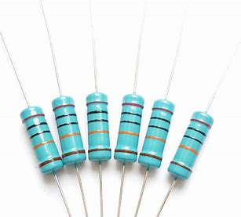

Fixed resistors are one type of linear resistors. A resistor is said to be a fixed resistor, if its value is fixed. The value of fixed resistor can’t be varied like a variable resistor as its value is determined at the time of manufacturing itself.

**LED**

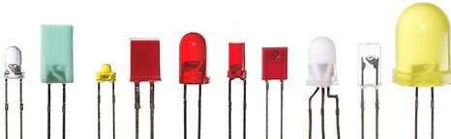

Light-emitting diode (LED) is a widely used standard source of light in electrical equipment. It has a wide range of applications ranging from your mobile phone to large advertising billboards. They mostly find applications in devices that show the time and display different types of data.

DIODE

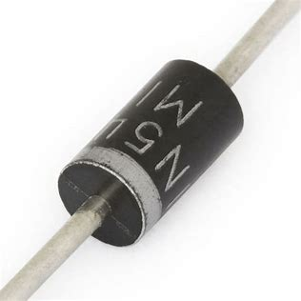

**diode**, an [electrical](https://www.britannica.com/science/electricity) component that allows the flow of [current](https://www.britannica.com/science/electric-current) in only one direction. In [circuit](https://www.britannica.com/technology/electric-circuit) diagrams, a diode is represented by a triangle with a line across one vertex.

**CERAMIC CAPACITOR**

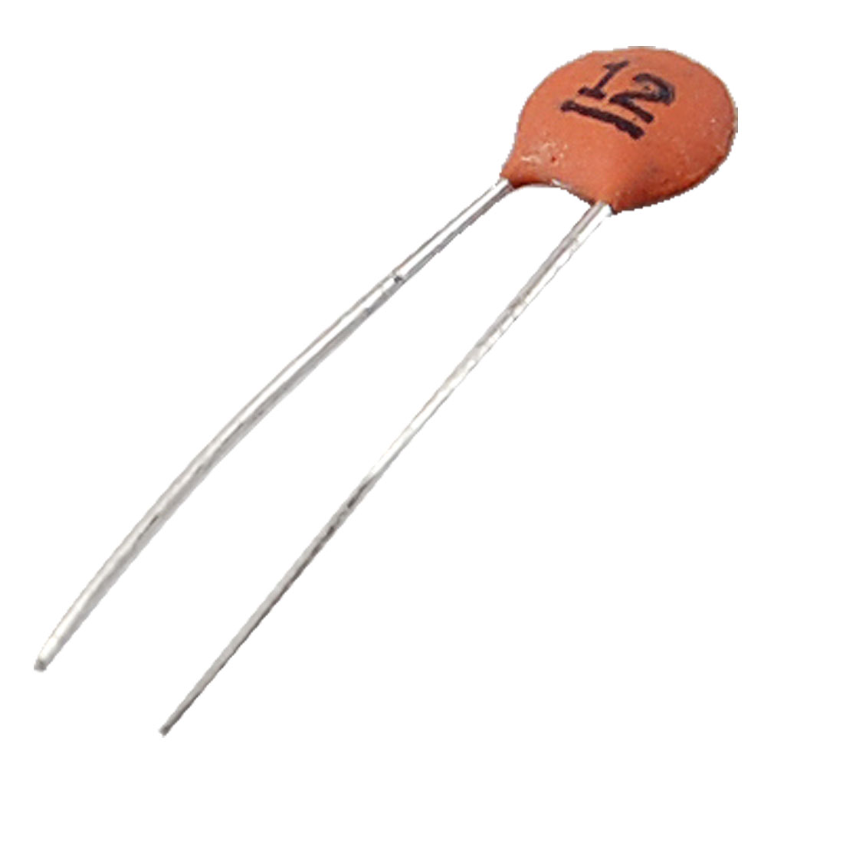

Ceramic capacitors are the common types of capacitors used in most of the electrical instruments as they are more reliable and cheaper to manufacture.

These capacitors consist of ceramic or porcelain discs and are said to exist in a non-polarized form which is used in various types of industries. Ceramic material is known to be an excellent dielectric because of its poor conductivity and also an efficient supporter of the [electrostatic fields](https://byjus.com/physics/electrostatics/).

**ELECTROLYTIC CAPACITOR:**

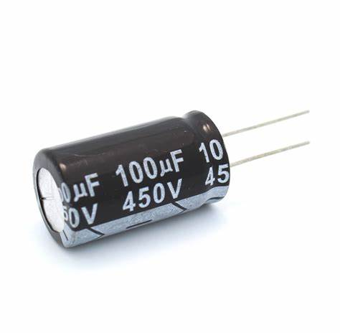

**Electrolytic Capacitors are generally used when very large capacitance values are required. Here instead of using a very thin metallic film layer for one of the electrodes, a semi-liquid electrolyte solution in the form of a jelly or paste is used which serves as a second electrode (usually the cathode).Dielectric is a very thin layer of oxide which is grown electro-chemically in production with the thickness of the film being less than ten microns. This insulating layer is so thin that it is possible to make capacitors with a large value of capacitance for a small physical size as the distance between the plates is very small.**

**MULTIMETER:**

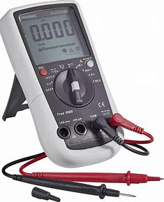

**Multimeter** is an instrument used to measure DC & AC voltages, DC & AC currents and resistances of several ranges. It is also called Electronic Multimeter or Voltage Ohm Meter (VOM).

**BATTERY:**



[Batteries](https://www.sparkfun.com/categories/54) are a collection of one or more cells whose chemical reactions create a flow of electrons in a circuit. All batteries are made up of three basic components: an anode (the '-' side), a cathode (the '+' side), and some kind of electrolyte (a substance that chemically reacts with the anode and cathode).

**How to Measure Current**

1. Insert the probes into the correct connections - this is required because there may be a number of different connections that can be used. Be sure to get the right connections as there may be separate connections for very low or very high current ranges.
2. Set switch to the correct measurement type (i.e. to measure current) and range for the measurement to be made. When selecting the range, ensure that the maximum for the particular range chosen is above that anticipated. The range on the multimeter can be reduced later if necessary. However by selecting a range that is too high, it prevents the meter being overloaded and any possible damage to the movement of the meter itself.
3. When taking the reading, optimise the range for the best reading. If possible adjust it so that the maximum deflection of the meter can be gained. In this way the most accurate reading will be gained.
4. Once the reading is complete, it is a wise precaution to place the probes into the voltage measurement sockets and turn the range to maximum voltage position. In this way if the meter is accidentally connected without thought for the range to be used, there is little chance of damage to the meter. This may not be true if it left set for a current reading, and the meter is accidentally connected across a high voltage point!

**How To Measure Resistance**

1. Choose the item whose resistance you wish to measure. For the most accurate measurement, test the resistance of a component individually.
2. Plug the test leads into the correct test sockets. On most multimeters, one test lead will be black and the other will be red.
3. Turn on the multimeter and select the best testing range. The resistance of a component can range from ohms (1 ohm) to megaohms (1,000,000 ohms).
4. Touch the multimeter leads to the ends of the component you are testing. ...
5. Turn off the multimeter. When you are done measuring all of your components, turn off the multimeter and unplug the leads for storage.

**How to Measure Voltage**

1. Turn the meter on
2. Set the meter range to accommodate the largest expected value - note: some DMMs will be auto ranging and it is only necessary to select the voltage capability. Note that DMMS are normally able to operate with both negative and positive values on the probing or red lead.
3. First probe the low voltage point - often this may be ground and there may even be an alligator / crocodile clip on the black or ground probe that can be connected to a suitable ground point. This saves trying to probe two points at once.
4. Probe the higher voltage point with the probe on the red lead.
5. If necessary, adjust the range switch to obtain the best reading.
6. Note the reading

**Observation Table:**

|  |  |  |  |
| --- | --- | --- | --- |
| **Sr.**  **No** | **Name of component** | **Theoretical value** | **Practical value using multimeter** |
| 1 | RESISTER | 10 | 9.56 |
| 2 | LED | WORKING | WORKING |
| 3 | CAPACITOR(POLARIZED) | 10 uF | 10.3 uF |
| 4 | TRANSISTOR | ----------------------- |  |
| 5 | WIRE | ----------------------- | WORKING |

**Conclusion:**

**We have studied about the basic electronics component and calculate the value of resistance and Current and voltage.**

# Experiment No. 2

**Aim: Plot and analyze the forward and reverse characteristics of PN junction Si / Ge diode and determine the knee voltage.**

**Virtual Lab Link:** http://vlabs.iitkgp.ernet.in/be/exp5/index.html

**Theory:**

**Function of a P-N junction diode in Forward Bias**

The positive terminal of battery is connected to the P side (anode) and the negative terminal of battery is connected to the N side(cathode) of a diode, the holes in the p-type region and the electrons in the n-type region are pushed toward the junction and start to neutralize the depletion zone, reducing its width. The positive potential applied to the p-type material repels the holes, while the negative potential applied to the n-type material repels the electrons. The change in potential between the p side and the n side decreases or switches sign. With increasing forwardbias voltage, the depletion zone eventually becomes thin enough that the zone's electric field cannot counteract charge carrier motion across the p–n junction, which as a consequence reduces electrical resistance. The electrons that cross the p–n junction into the p-type material (or holes that cross into the n-type material) will diffuse into the nearby neutral region. The amount of minority diffusion in the near-neutral zones determines the amount of current that may flow through the diode.

## Function of a P-N junction diode in Reverse Bias

The positive terminal of battery is connected to the N side(cathode) and the negative terminal of battery is connected to the P side(anode) of a diode. Therefore, very little current will flow until the diode breaks down.

**Circuit Diagram:**

Forward Bias-Si Diode

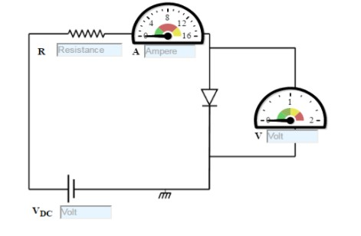

Figure:1

Reverse Bias-Si Diode

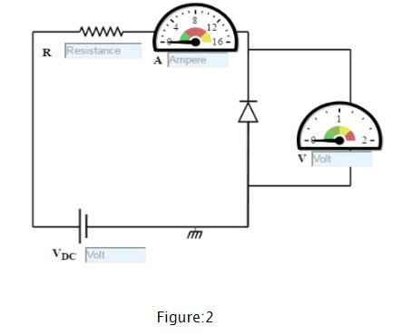

**Procedure:**

Forward Bias-Si Diode

1. Set DC voltage to 0.2 V.
2. Select the diode.
3. Set the resistor.
4. Voltmeter is placed parallel to Silicon diode and ammeter series with resistor.
5. The positive side of battery to the P side(anode) and the negative of battery to the N side(cathode) of the diode.
6. Now vary the voltage upto 5V and note the Voltmeter and Ammeter reading for particular DC voltage .
7. Take the readings and note Voltmeter reading across Silicon diode and Ammeter reading.
8. Plot the V-I graph and observe the change.
9. Calculate the dynamic resistance of the diode. rd=ΔV/ΔI
10. Therefore, from the graph we see that the diode starts conducting when the forward bias voltage exceeds around 0.6 volts (for Si diode). This voltage is called cut-in voltage.

Reverse Bias-Si Diode

1. Set DC voltage to 0.2 V.
2. Select the diode.
3. Set the resistor.
4. Voltmeter is placed parallel to Silicon diode and ammeter series with resistor.
5. The positive terminal of battery is connected to the N side(cathode) and the negative terminal of battery is connected to the P side(anode) of a diode.
6. Now vary the voltage upto 30V and note the Voltmeter and Ammeter reading for DC voltage.
7. Take the readings and note Voltmeter reading across Silicon diode and Ammeter reading.
8. Plot the V-I graph and observe the change.

**Connection Circuit using virtual lab:**

Forward Biased SI Diode

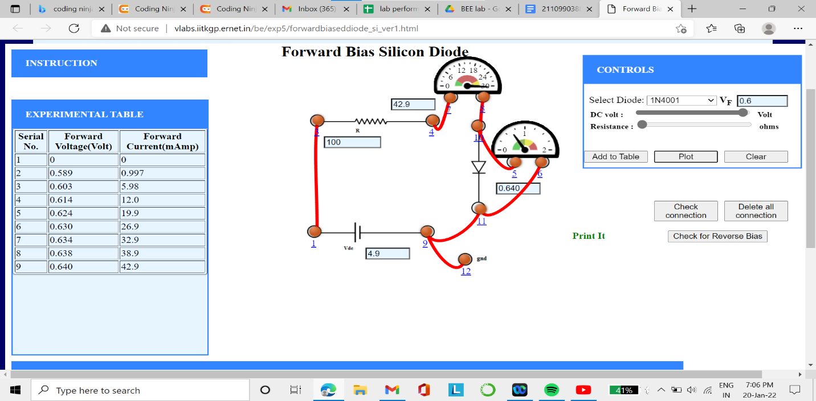

Reverse bias-SI Diode

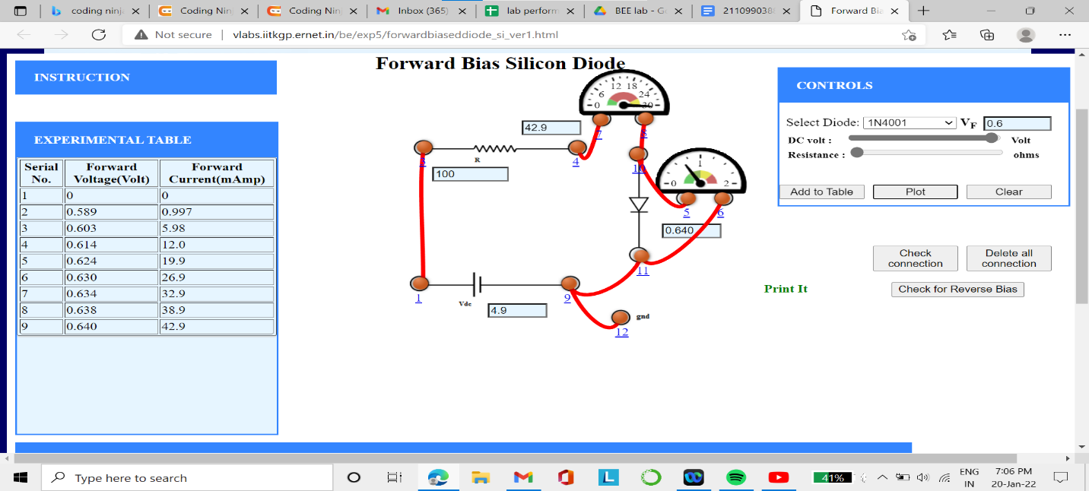

**Observation Table:**

**Forward bias-Si Diode**

|  |  |  |  |
| --- | --- | --- | --- |
| **Sr. No** | **DC voltage (V)** | **Forward voltage**  **(v)** | **Current (mA)** |
| **1** | **0.6** | **0.566** | **0.4** |
| **2** | **0.9** | **0.573** | **1.26** |
| **3** | **1.4** | **0.585** | **3.36** |
| **4** | **2.8** | **0.603** | **9.23** |
| **5** | **4.7** | **0.616** | **17.2** |

**Calculate Value of static resistance, :** Rd = V/I **: 0.285**

**Value of dynamic resistance, :** rd = ∆V/∆I **:  0.163**

**Graph:**

**Forward Bias SI Diode**

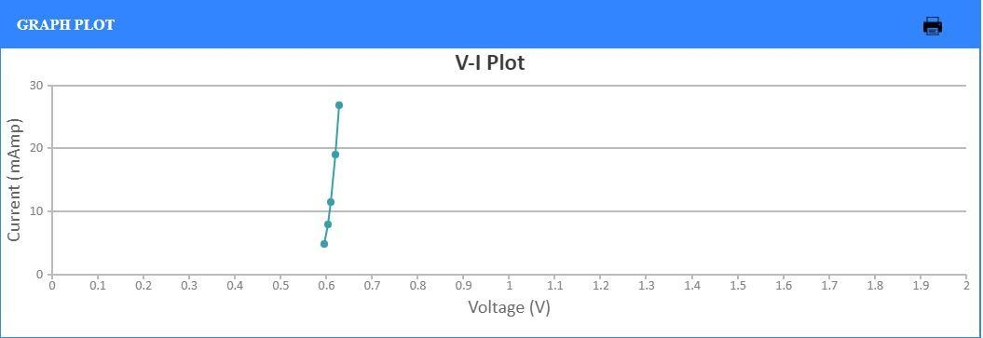

**Observation Table:**

Reverse Bias-Si Diode

|  |  |  |  |
| --- | --- | --- | --- |
| **Sr. No** | **DC voltage (V)** | **Forward voltage**  **(v)** | **Current (mA)** |
| 1 | 30.2 | 29 | 22.878 |
| 2 | 29.1 | 27.9 | 0.100 |
| 3 | 27.25 | 26.1 | 0.100 |
| 4 | 23.8 | 22.7 | 0.100 |
| 5 | 13 | 22.7 | 0.100 |

**Calculate Value of static resistance,** Rd = V/I**: 26**

**Value of dynamic resistance,** rd = ∆V/∆I **:**

**Graph:**

Reverse Bias-Si Diode

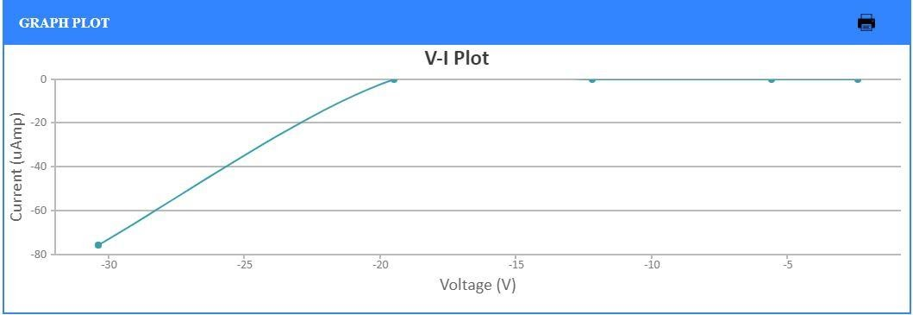

**Observation Table:**

Forward Bias-Ge Diode

|  |  |  |  |
| --- | --- | --- | --- |
| **Sr. No** | **DC voltage (V)** | **Forward voltage**  **(v)** | **Current (mA)** |
| 1 | **4.05** | **0.283** | **3.75** |
| 2 | **6.25** | **0.293** | **5.93** |
| 3 | **9.15** | **0.298** | **8.85** |
| 4 | **11.9** | **0.302** | **11.6** |
| 5 | **15.75** | **0.305** | **15.4** |

**Calculate Value of static resistance,** Rd = V/I**: 1.13**

**Value of dynamic resistance,** Rd = ∆V/∆I**:  1**

**Graph:**

Forward Bias-Ge Diode

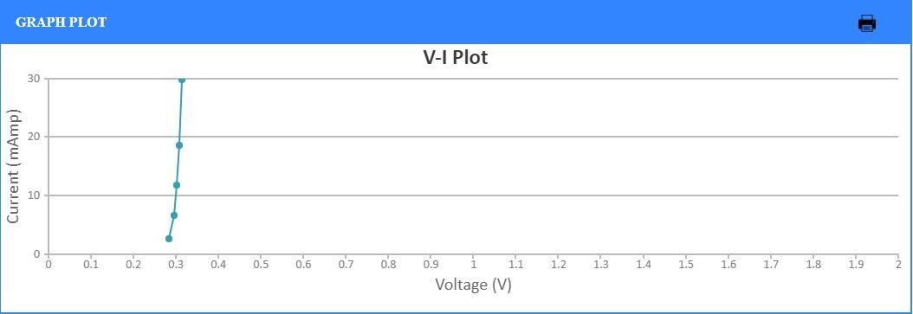

**Observation Table:**

Reverse Bias-Ge Diode

|  |  |  |  |
| --- | --- | --- | --- |
| **Sr. No** | **DC voltage (V)** | **Forward voltage (v)** | **Current (mA)** |
| 1. | 6.6 | 6.6 | 0 |
| 2. | 8.25 | 8.25 | 0 |
| 3. | 11.35 | 11.35 | 0 |
| 4. | 17.5 | 17.5 | 0 |
| 5. | 20.7 | 20.7 | 0 |

**Calculate Value of static resistance,** Rd = V/I **:**

**Value of dynamic resistance,** rd = ∆V/∆I **:**

**Graph:**

Reverse Bias-Ge Diode

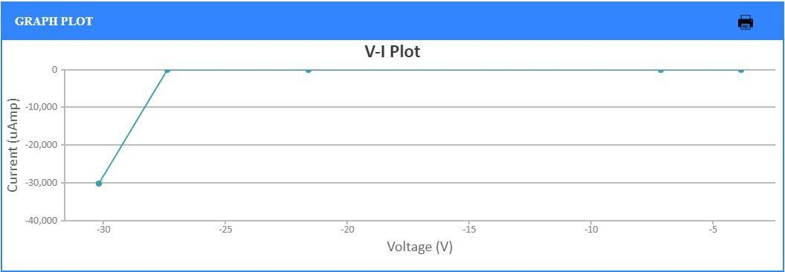

**Conclusion:**

1. **The change in current when voltage across diode is less than knee voltage is zero during forward biasing**
2. **The current increases when voltage across diode exceeds knee voltage during forward biasing.**
3. **The value of peak inverse voltage across diode in reverse biasing is 30V**

# Experiment No. 3

**Aim: Analyze Zener diode as voltage regulator and observe the output voltage with variable input voltage and fixed load resistance for zener diodes with different breakdown voltages.**

**Virtual Lab Link:**

**Theory:**

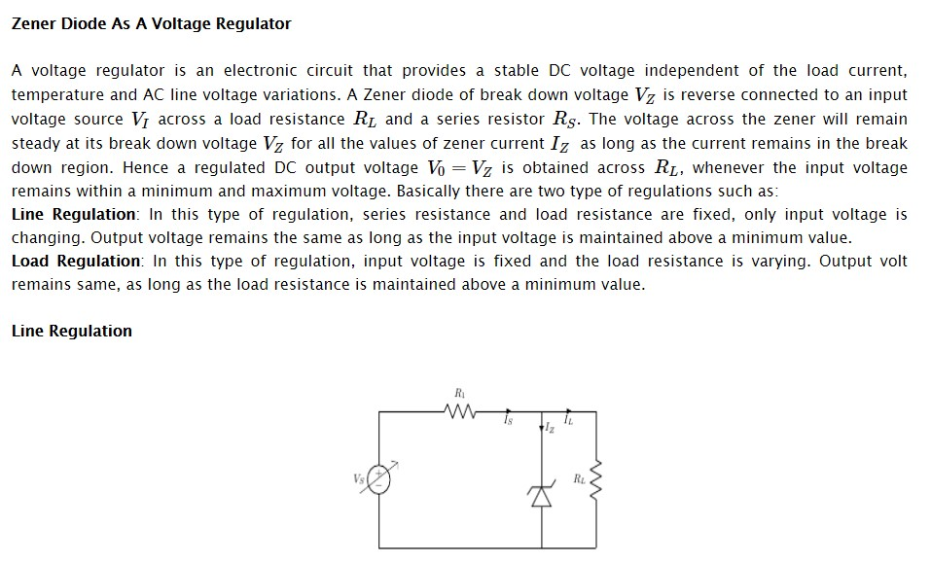

**Circuit Diagram:**

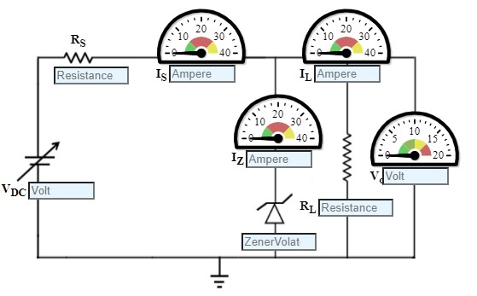

**Procedure:**

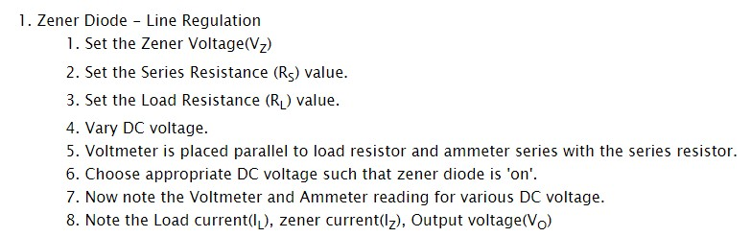

**Connection Circuit using virtual lab:**

Zener Diode-Line Regulation

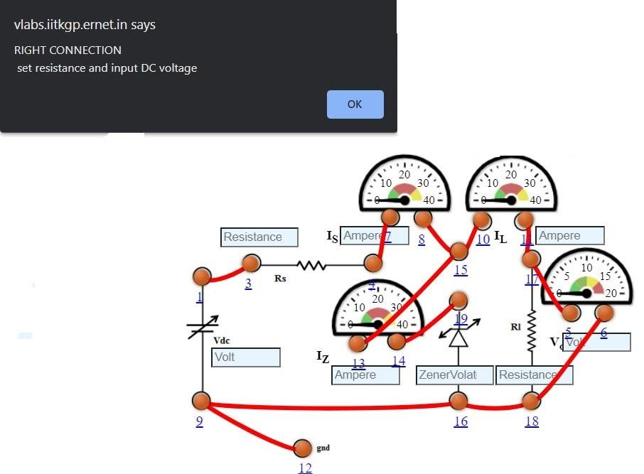

Zener Diode-Load Regulation

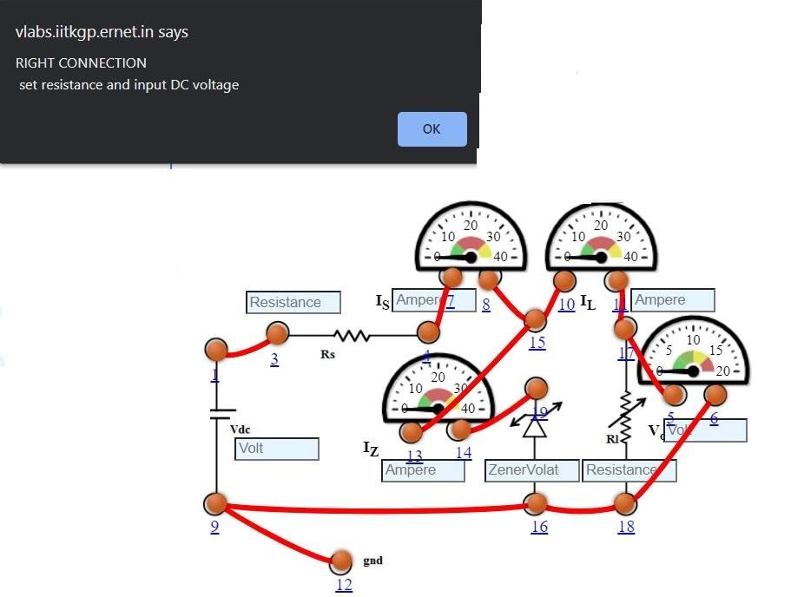

**Observation Table:**

Zener Diode-Line Regulation

|  |  |  |  |  |
| --- | --- | --- | --- | --- |
| **Sr.**  **No** | **DC**  **voltage (V)** | **LOAD CURRENT(mA)** | **ZENER CURENT(mA)** | **Output voltage**  **(v)** |
| 1 | 2.6 | 2.55 | 0 | 2.6 |
| 2 | 5.2 | 2.55 | -2.450 | 5.10 |
| 3 | 8 | 2.55 | 0.350 | 5.10 |
| 4 | 12.8 | 2.55 | 5.150 | 5.10 |
| 5 | 15.4 | 2.55 | 7.750 | 5.10 |

**Graph:**

Zener Diode-Line Regulation

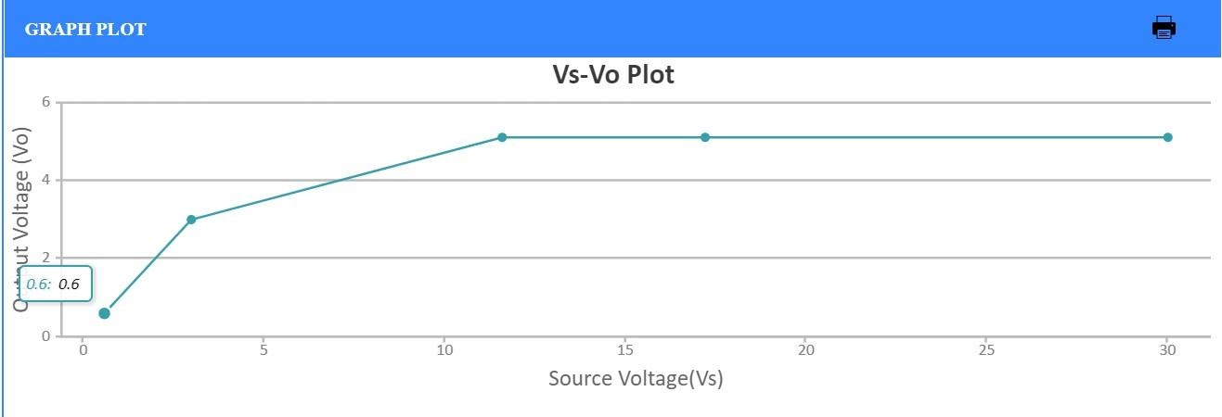

**Observation Table:**

Zener Diode-Load Regulation

|  |  |  |  |  |  |  |
| --- | --- | --- | --- | --- | --- | --- |
| **Sr. No** | **DC voltage (V)** | **Breakdown voltage** Vz | Is**(mA)** | IL**(mA)** | Iz**(mA)** | **Output voltage** Vo**(v)** |
| 1. | 6 | 5.1 | 9 | 34 | 0 | 6 |
| 2. | 6 | 5.1 | 9 | 16.2 | 0 | 6 |
| 3. | 6 | 5.1 | 9 | 9.64 | 0 | 6 |
| 4. | 6 | 5.1 | 9 | 6.06 | 2.94 | 5.10 |
| 5. | 6 | 5.1 | 9 | 4.08 | 4.92 | 5.10 |

**Plot:**

Zener Diode-Load Regulation

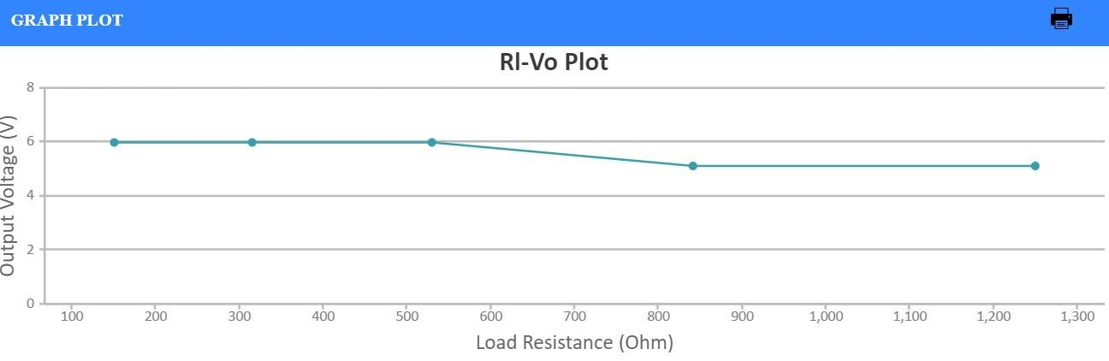

**Conclusion:**

**We have learnt the working of a zener diode in reverse bias and its significance a voltage regulator**

# Experiment No. 4

**AIM: Study and observe the output waveform of half-wave and full wave rectifiers on CRO.**

**Virtual Lab Link:** <http://vlabs.iitkgp.ernet.in/be/exp6/index.html>

**Theory:**

**RECTIFIER**

rectifier is an electronic device that converts an alternating current into a direct current by using one or more P-N junction diodes. A diode behaves as a one-way valve that allows current to flow in a single direction. This process is known as rectification.

A rectifier can take the shape of several physical forms such as solid-state diodes, vacuum tube diodes, mercury-arc valves, silicon-controlled rectifiers, and various other silicon-based semiconductors switches.

**HALF WAVE RECTIFICATION:**

Half-wave rectifiers transform AC voltage to DC voltage. A halfwave rectifier circuit uses only one diode for the transformation.

A halfwave rectifier is defined as a type of rectifier that allows only one-half cycle of an AC voltage waveform to pass while blocking the other half cycle.

**FULL WAVE RECTIFICATION:**

A full wave rectifier is defined as a rectifier that converts the complete cycle of alternating current into pulsating DC.

Unlike halfwave rectifiers that utilize only the halfwave of the input AC cycle, full wave rectifiers utilize the full cycle. The lower efficiency of the half wave rectifier can be overcome by the full wave rectifier.

**Procedure:**

**HALF WAVE RECTIFICATION:**

1. A high AC voltage is applied to the primary side of the step-down transformer. The obtained secondary low voltage is applied to the diode.
2. The diode is forward biased during the positive half cycle of the AC voltage and reverse biased during the negative half cycle.
3. The final output voltage waveform is as shown in the figure below:

**FULL WAVE RECTIFICATION:**

1. Set the resistor RLRL.
2. Click on 'ON' button to start the experiment.
3. Click on 'Sine Wave' button to generate input waveform
4. Click on 'Oscilloscope' button to get the rectified output.
5. Vary the Amplitude, Frequency, volt/div using the controllers.
6. Click on "Dual" button to observe both the waveform.
7. Channel 1 shows the input sine waveform, Channel 2 shows the output rectified waveform.
8. Calculate the Ripple Factor. Theoretical Ripple Factor=0.483.

**Circuit Diagram:**

**HALF WAVE RECTIFIER**

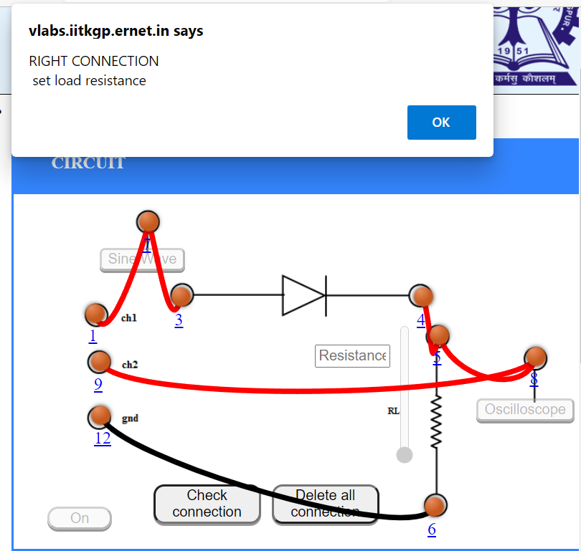

**FULL WAVE RECTIFIER:**

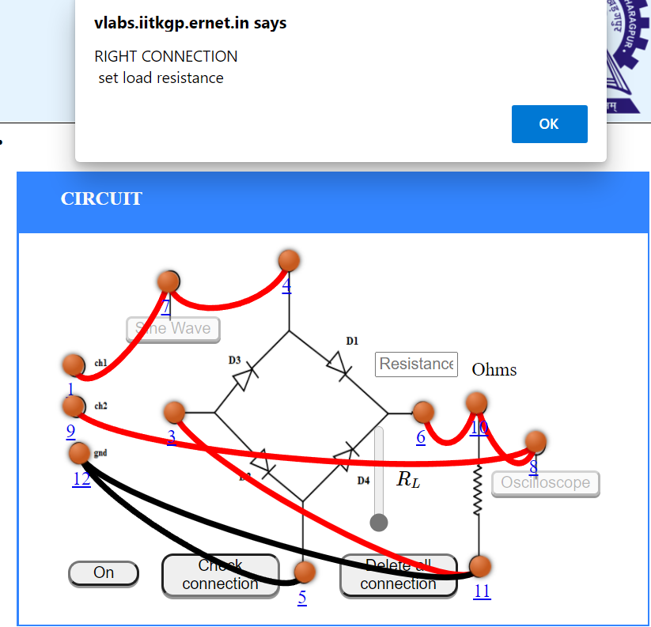

**Waveforms:**

**HALF WAVE RECTIFIER:**

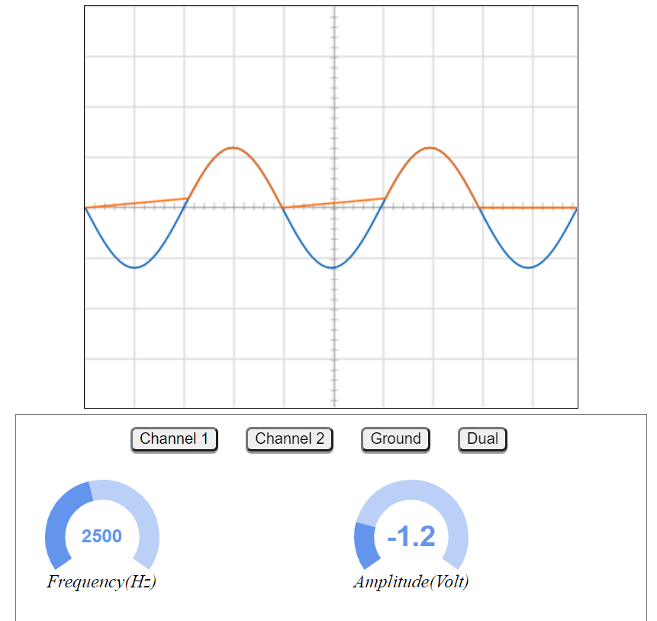

**FULL WAVE RECTIFIER:** 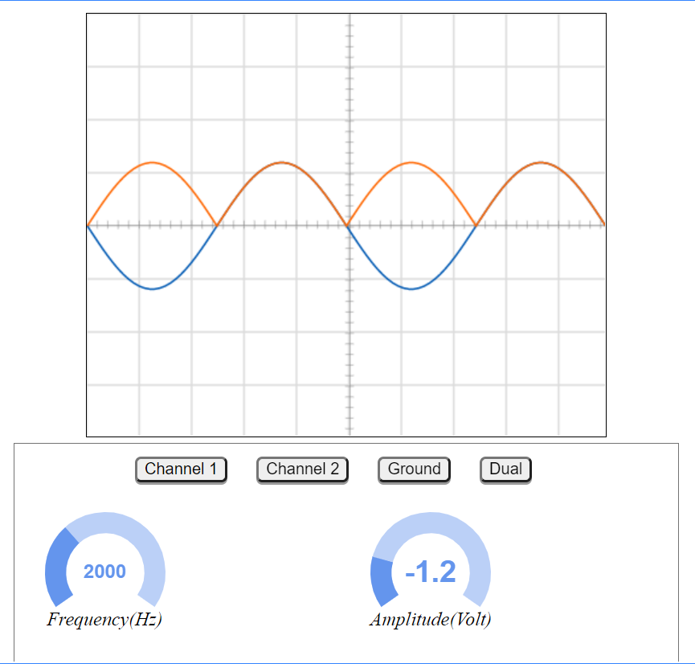

# Experiment No. 5

**Aim: Analyze the NPN / PNP transistors in common emitter configuration and plot their input and output characteristics.**

**Virtual Lab Link:** <http://vlabs.iitkgp.ernet.in/be/exp11/index.html>

**Theory:**

 CUT-OFF REGION:

Cutoff region This is the**region in which transistor tends to behave as an open switch**. The transistor has the effect of its collector and base being opened. The collector, emitter and base currents are all zero in this mode of operation.

FORWARD-ACTIVE REGION:

This is the region in which transistors have many applications. This is also called as **linear region**. A transistor while in this region, acts better as an **Amplifier**.

### **Saturation region**

This is the region in which transistor tends to behave as a closed switch. The transistor has the effect of its collector and Emitter being shorted. The collector and Emitter currents are maximum in this mode of operation.

**Circuit Diagram:**

BJT - COMMON EMITTER INPUT CHARACTERISTICS

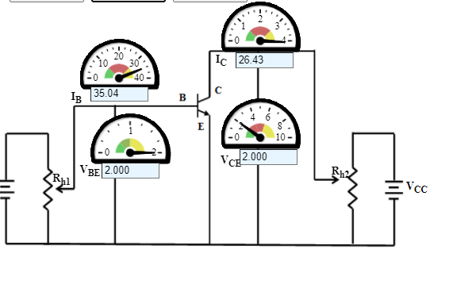

BJT-COMMON EMITTER OUTPUT CHARACTERISTICS

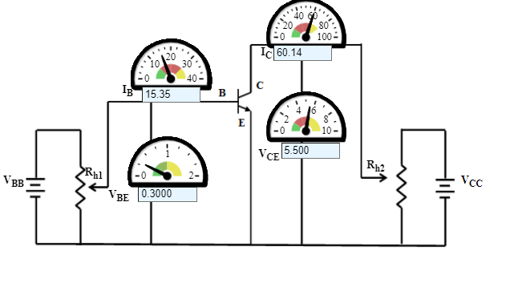

**Procedure:**

## BJT COMMON EMITTER-INPUT CHARACTERISTICS:

1. Initially set rheostat Rh1 = 1 Ω and rheostat Rh2 = 1 Ω
2. Set the Collector-Emitter Voltage(VCE) to 1 V by adjusting the rheostat Rh2
3. Base Emitter Voltage(VBE) is varied by adjusting the rheostat Rh1.
4. Note the reading of Base current(IB)in micro Ampere.
5. Click on 'Plot' to plot the I-V characteristics of Common-Emitter configuration. A graph is drawn with VBE along X-axis and IB along Y-axis.
6. Click on 'Clear' button to take another sets of readings

Now set the Collector-Emitter Voltage(VCE) to 2 V, 3 V, 4 V

**BJT Common Emitter - Output Characteristics**

1. Initially set rheostat Rh1 = 1 Ω and rheostat Rh2 = 1 Ω
2. Set the Base current(IB)15 uA by adjusting the rheostat Rh1
3. Vary the Collector-Emitter Voltage(VCE)is varied by adjusting the rheostat Rh2.
4. Note the reading of Collector current(IC).
5. Click on 'Plot' to plot the I-V characteristics of Common-Emitter configuration. A graph is drawn with VCE along X-axis and IC along Y-axis.
6. Click on 'Clear' button to take another sets of readings

7. Now set the Base Current(IB) to 20 uA

**Connection Circuit using virtual lab:**

**Paste here your circuit Observation Table:**

**Input characteristics:**

|  |  |  |  |  |  |  |
| --- | --- | --- | --- | --- | --- | --- |
|  | **Output voltage VCE =** | | **Output voltage VCE**  **=** | | **Output voltage VCE =** | |
| **Sr.**  **No** | **Input voltage**  **VBE(V)** | **(microA)** | **Input voltage**  **VBE(V)** | **(microA)** | **Input voltage**  **VBE(V)** | **(microA)** |
|  |  |  |  |  |  |  |
|  |  |  |  |  |  |  |
|  |  |  |  |  |  |  |
|  |  |  |  |  |  |  |

**Graph (Input characteristics) :**

**Output characteristics:**

|  |  |  |  |  |  |  |
| --- | --- | --- | --- | --- | --- | --- |
|  | **Input current =** | | **Input current =** | | **Input current =** | |
| **Sr.**  **No** | **Output voltage**  **VCE(V)** | **(microA)** | **Output voltage**  **VCE(V)** | **(microA)** | **Output voltage**  **VCE(V)** | **(microA)** |
|  |  |  |  |  |  |  |
|  |  |  |  |  |  |  |
|  |  |  |  |  |  |  |
|  |  |  |  |  |  |  |

**Graph (Output characteristics) :**

**Conclusion:**

# Experiment No. 6

**Aim: Analyze the truth tables of various basic digital gates and implement 2-input XOR and 2-input XNOR gate using basic gates.**

**Virtual Lab Link:** <http://vlabs.iitkgp.ernet.in/dec/exp3/index.html>

**Theory:**

Logic gates are the basic building blocks of any digital system. It is an electronic circuit having one or more than one input and only one output. The relationship between the input and the output is based on a **certain logic**. Based on this, logic gates are named as AND gate, OR gate, NOT gate etc

## AND Gate

It is a digital logic gate. It has an output that is frequently at logic level “0” and goes “HIGH” to a logic level “1” when all of its inputs are at logic level “1”. The output of AND gate returns “LOW” when any of its inputs are at a logic level “0”.

The Boolean expression for AND gate is Q= A.B

## OR Gate

OR gate is also a digital logic gate that has an output that is frequently at logic level ’0’, but goes ’HIGH’ to a logic level ’1’ when any of its inputs are at logic level ’1’. The output of a logic OR gate returns ’LOW’ again when all of its inputs are at a logic level ’0’.

The Boolean expression for OR gate is indicated as Q = A+B.

## NOT Gate

In digital electronics, the NOT gate is also referred to as inverting buffer or a digital inverter element. A NOT gate is a single input device. It has an output level that is provided at logic level ‘1’. It goes ‘LOW’ to a logic level ‘0’ whenever the single input is at logic level ‘1’. The output from a NOT gate returns ’HIGH’ when its input is at logic level ’0’.

The Boolean expression of NOT gate is Q=A

.

## NAND Gate

NAND gate is a mixture of AND gate with an inverter or NOT gate linked in series. It has an output that is frequently at logic level ’1’ and only goes ’LOW’ to logic level ’0’ when all of its inputs are at logic level “1”.

The Boolean expression of the NAND gate is Q= A.B¯

## NOR Gate

NOR gate is a mixture of OR gate with a NOT gate linked in a series. The NOR gate has an output that is generally at logic level ’1’ and only goes ’LOW’ to logic level ’0’ when any of its inputs are at logic level ’1’.

The Boolean expression of NOR gate is Q= A+B¯

## Exclusive-OR/ XOR GATE

It is a circuit that will give a high output if one of its inputs is high but not both of them. The XOR operation is defined by an encircled plus sign.

The Boolean expression is Q= (A⊕⊕B) = A.B+A.B

## Exclusive-NOR Gate

The Exclusive-NOR gate function is a digital logic gate that is an interdependent form of the Exclusive-OR function. This function is at logic level ’1’, but it goes ’LOW’ to logic level ’0’ whenever any of its inputs are at logic level ’1’.

The Boolean expression is Q¯Q¯ = (A⊕⊕B¯B¯) = A.B + A.B.

**Circuit Diagram:**

**XOR CIRCUIT**

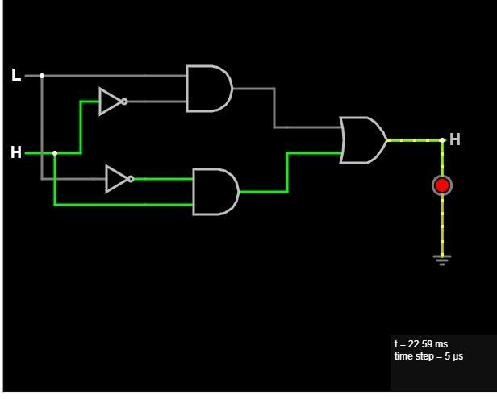

**X-NOR CIRCUIT:**

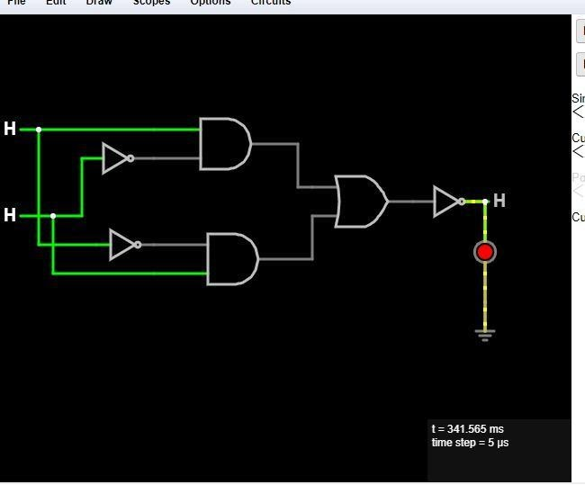

**Truth table of all gates**

**AND GATE:**

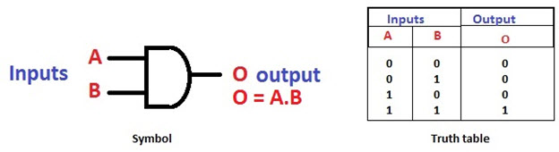

#### OR Gate

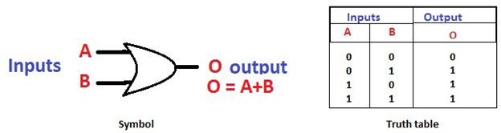

#### NOT Gate

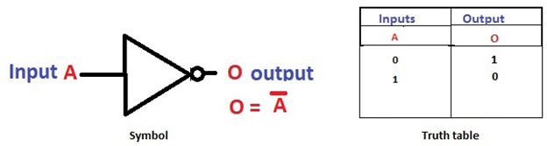

#### NAND Gate

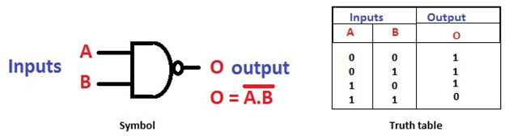

#### NOR Gate

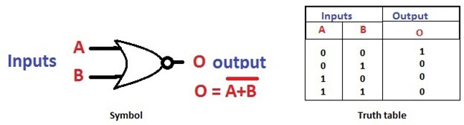

#### Exclusive-OR Gate

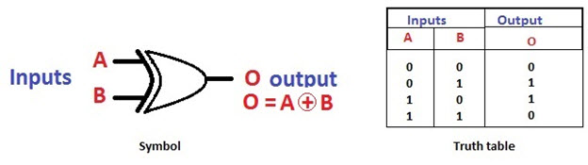

#### Exclusive-NOR Gate

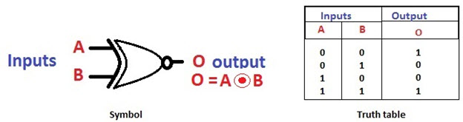

**Conclusion:**

AND, NOT and OR gates are the basic logic gates. By using these gates we can create any logic gate by combining them. Where NAND and NOR gates are called universal gates. These gates have a particular property with which they can create any logical Boolean expression if designed in a proper way.

# Experiment No. 7

**Aim: Study the operation of astable, monostable multivibrators using IC-555 timer.**

**Virtual Lab Link:** http://vlabs.iitkgp.ac.in/psac/newlabs2020/vlabiitkgpAE/exp4/astable_multivibrator.html

**Theory:**

The **555 Timer** IC got its name from the three 5KΩ5KΩ resistors that are used in its voltage divider network. This IC is useful for generating accurate time delays and oscillations

# Astable Multivibrator Circuits

The IC 555 astable multivibrator is a configuration where the IC 555 output continuously switches between an ON state and an OFF state at a given frequency, determined by its RC timing components. Since in this configuration, the output of the IC 555 is never in a stable state, it is called an astable multivibrator.

**Monostable multivibrator**

As the name indicates, only one state is stable and the other one is called unstable or quasi stable state. 555 timer IC remains in Stable state until the **external triggering** is applied

**Circuit Diagram:**

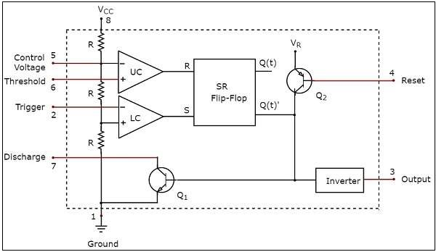

**Astable**

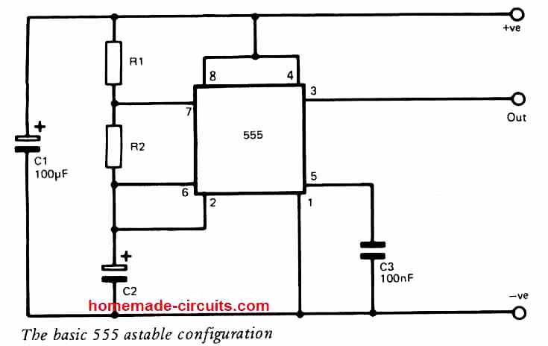

**Mono Stable**

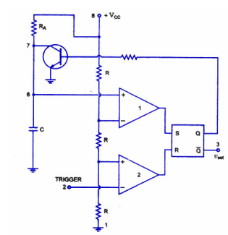

**Connection Circuit using virtual lab:**

**Astable**

## 

**Monostable**

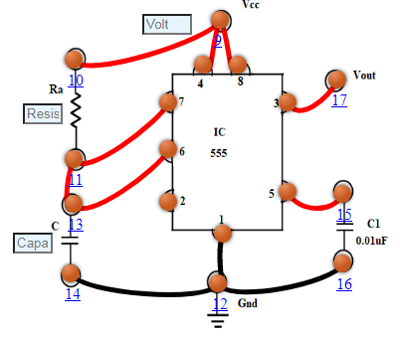

**Waveforms:**

***Astable Multivibrator***

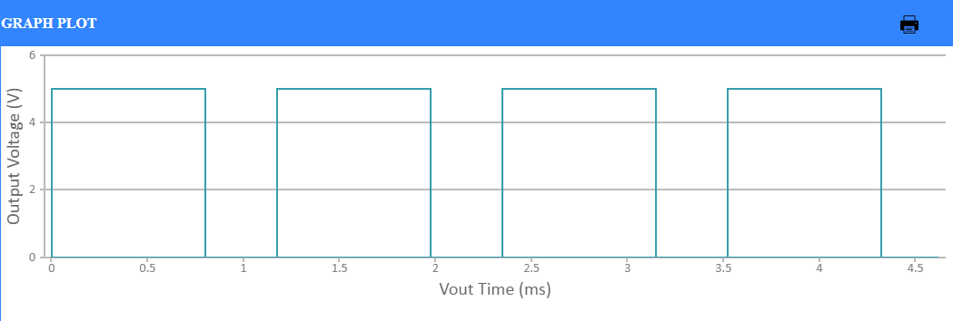

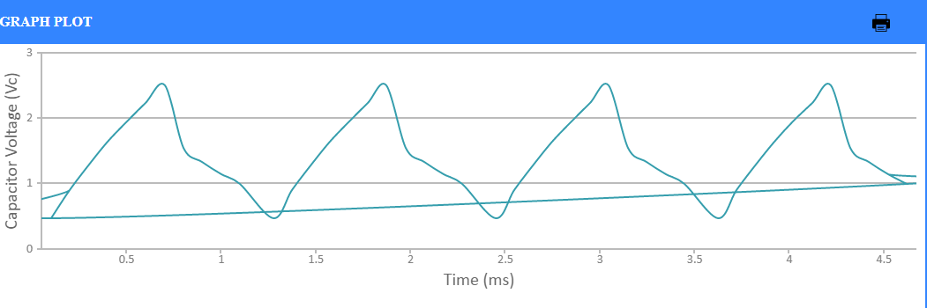

***Mono Stable Multivibrator***

**Trigger Input Voltage**

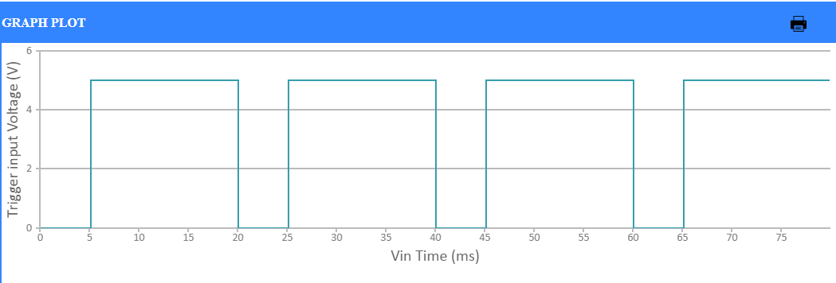

**Output Voltage**

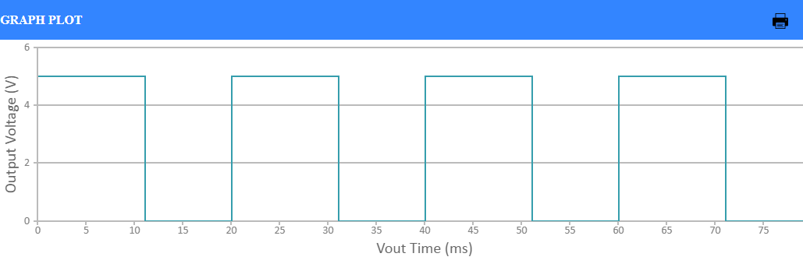

**Capacitor Voltage**

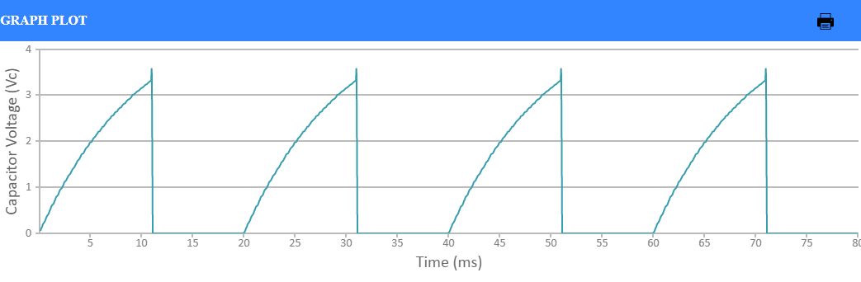

**Conclusion:** In this experiment we have successfully designed a 555 Astable and Monostable multivibrator as per given specifications.

**PROJECT**

**Project Title: LED CIRCUIT USING TRANSISTER**

**Components used in circuit:**

1. Breadboard
2. 2 Transistor (BC547) (NPN and PNP)
3. 1 Capacitor(100uf)
4. 1 LED
5. Jumper Wire
6. Battery(9V)
7. 3 Resistor

**Circuit diagram:**

**Circuit working: yes we can confirm by knowing that LED is glowing**

**Image (of your project on breadboard):**

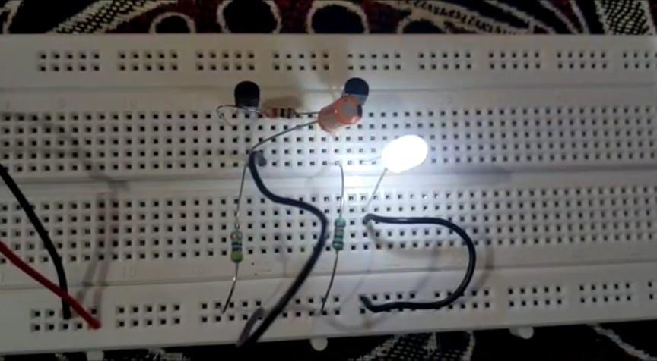

**Video link:**

**https://drive.google.com/file/d/1gINvwbZtJ6W93nlMfPO5lNaEMS-e15TA/view?usp=sharing**

**Learning Outcome: learnt how to use breadboard and use of various components used in the project**

**Reference link:**

<https://www.youtube.com/watch?v=TTQnhIkw4Bk>

https://www.youtube.com/watch?v=gTn_HmzXYLo